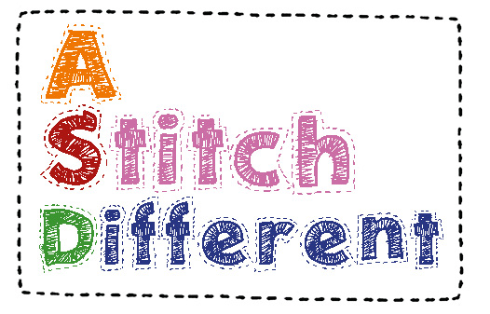
Outer Fabric Choice, Fleece, Navy, Royal Blue, Black, Red, Pink, Purple or special order?
Sweat shirting- Grey Marl or Navy or special order ?
Style - Hooded, Collar or V neck?
Fastening - Zip, Velcro or Button?
Pockets - Angled, Patch, Inset or Non ?
Any special requirements?
A-Chest……………………………….…………..cm
B-Hips………………………………………….…..cm
C-Length neck to hips……………………cm
D-Length under arm to hips…………cm
E-Shoulder to shoulder…………………cm
F-Neck to shoulder………………………..cmName 
Address




Users body weight            KG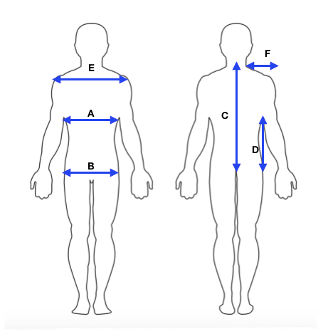

Please email to [mandy@astitchdifferent.co.uk](mailto:mandy@astitchdifferent.co.uk)

Shoulder to Shoulder

Information Needed for Your Bespoke

Weighted Vest

A & B

Measure all way around chest & hips over usual clothing